Mid Holderness Ward Newsletter – March 2025
Detailed crime and ASB data for your area can be obtained by visiting www.police.uk and following the ‘Find your Neighbourhood’ link.
Meet Your Community Police Team
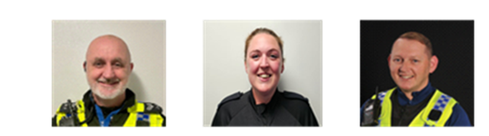
Inspector Ian Foster Sergeant Mick McLaughlin PC Maria Adlington PCSO Darren Bainton
What’s happening in Your Area & Community Priorities?

41 crimes reported during February.
Humbertalking has set our priorities, this month we are to:
- Prevention of Residential dwelling Burglaries.
- Improving Road Safety.

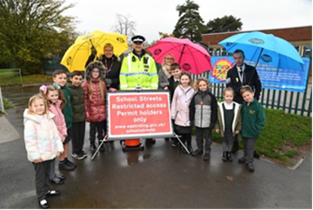
QR – please scan to visit My Community Alert & take part in our survey
Here’s a summary of crimes that have been reported across Mid Holderness last month:
Domestic Related incidents: (five investigations)
Harassment x1, Assault x 1, Burglary x1, damage to property x2
Residential Burglary reports: (three investigations)
03/02/2025 Burglary Dawnay Road, BILTON attempt made to snap door lock.
06/02/2025 Hanoi Burglary Lambwath Road, NEW ELLERBY – keys taken from property and used to steal vehicle BMW M3.
17/02/2025 Attempt garage Burglary Quilter Drive, BILTON persons seen on CCTV to try door handles.
Business Burglary reports: (one investigation)
03/02/2025 Burglary Ferry Road, WAWNE – various Tools stolen from Storage Containers
Thefts: (one investigation)
04/02/2025 Theft Main Road, BILTON – Make off without payment for fuel.
Vehicle Crime: (four investigations)
04/02/2025 theft from vehicle, Beech Avenue, BILTON racksack stolen.
08/02/2025 damage to a vehicle, Main Road BILTON keys used to scratch paintwork.
Damage: (no investigations)
Public order x 3, assault x 3, Blackmail x 1, neighbour disputes x1, Wildlife issue x1, Fraud x2, Sexual Offence x3, Firearm possession x1, Harassment x4, Malicious Communication x1 and anti-social behaviour x1 reported in February across the Mid Holderness ward area.

Humber-talking has set our priorities, this month we are to:
- Preventing Residential dwelling Burglaries.
This period is always one of our busiest, however, we would like to offer reassurance to residents and a stark reminder to those intent of causing harm or committing offences, that we are out in force and ready to act against anyone involved in vehicle crime.
UPDATE - During February, reports of burglary and theft of vehicles fell to 3 reports.

Action - aims to:
- reduce burglary related crime.
- raise awareness within the local community about property security.
- provide crime prevention advice to community members.

Intended outcome:
The intended outcomes are to:
- reduce the number of recorded crimes related to Burglaries.
- enhance security measures to protect residents.
UPDATE: A man has been charged following reports of an attempt burglary on Dawnay Road in Bilton, Harlee Hinchliffe, 18-years-old, of Perran Close in Hull has been charged with burglary, attempt burglary and dangerous driving.
He was remanded into custody to appear at Hull Magistrates Court at a later date.
A man has been arrested and released on Police bail for a Hanoi burglary in Skirlaugh on 31/01/25.

2. Improving Road Safety

Action – aims to:
- As we enter the spring months, members of the Holderness Policing Team will continue to be out and about policing our roads to promote safe behaviour and enforcement of traffic laws.
- Officers will continue to support Bilton Primary School to reduce traffic in the village and encourage families to walk or cycle to school.
Intended outcome:
The intended outcomes are to:
- Education & awareness campaigns to reduce the number of casualties on our roads.
- Create a culture of road safety where individuals understand and practices safe behaviours.
How you can help
Your local Neighbourhood Policing Team appreciates the importance of being in the right place, at the right time, for the right reasons to reassure the public, improve public confidence and reduce crime and anti-social behaviour in the area in which we all live and work.
We encourage all residents to call and report any issues where they live so that we can deal with any issues and step up our patrols in that area.
If you feel that there are other issues affecting you or your local community that should be given priority, please inform your local councillors or your Neighbourhood Policing Team.
News and Appeals
Please visit our website www.humberside.police.uk for the latest news & appeals
FACEBOOK users did you know? You can find out more about the work of your local officers and teams by liking their Facebook accounts: Please visit Humberside Police – East Riding of Yorkshire South www.facebook.com/HumberbeatERYS
Twitter (X) users can keep up to date with events, alerts and traffic news within Mid Holderness by following the community team @HumberbeatERYS and @PCSODarrenB
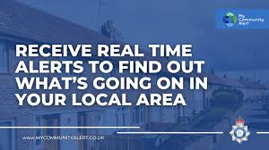 My Community Alert - free sign up

Engagements: In March 2025, the dates and locations are as follows:
6th- Thursday 7pm Wawne Parish Council @ Village Hall, Main Street, WAWNE
10th- Monday 7pm Aldbrough Parish Council @ ALDBROUGH Primary School
11th- Tuesday 7pm Bilton Parish Council @ Village Hall, Main Road, BILTON
15th- Saturday 11:30am the Village Hall, Swine Lane, CONISTON
Schools will be visited during the morning and afternoon commute.

PCSO Darren Bainton



Tips for protecting yourself online: #DontBeExposed
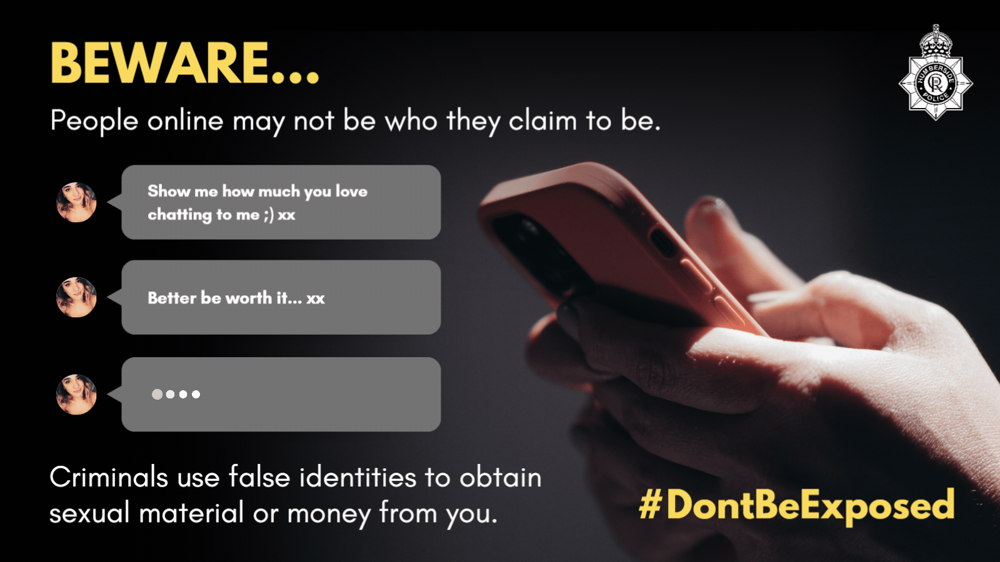
If you are chatting to new people online:
•Review your privacy settings. Criminals are less likely to target you if they can’t see who your friends and family are.
• If you’re not comfortable speaking to the person or being contacted by someone you don’t know, end the chat quickly.
• If you have any doubts about the person or are worried you are being targeted, report it.

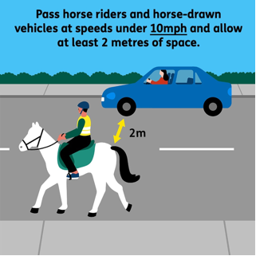 Overtaking when driving or cycling
You may cross a double-white line if necessary (provided the road is clear) to overtake someone cycling or riding a horse if they are travelling at 10 mph or less (Rule 129).
There is updated guidance on safe passing distances and speeds for people driving or riding a motorcycle when overtaking vulnerable road users, including:
• leaving at least 1.5 metres (5 feet) when overtaking people cycling at speeds of up to 30mph, and giving them more space when overtaking at higher speeds
• passing people riding horses or driving horse-drawn vehicles at speeds under 10 mph and allowing at least 2 metres (6.5 feet) of space
• allowing at least 2 metres (6.5 feet) of space and keeping to a low speed when passing people walking in the road (for example, where there’s no pavement)
• Wait behind them and do not overtake if it’s unsafe or not possible to meet these clearances.


On the school Run or having a day out with the family?

Remember, children must normally use a child car seat until they’re 12 years old or 135 cm tall, whichever comes first, to keep them safe. Go to our friends at Good Egg Safety for more information
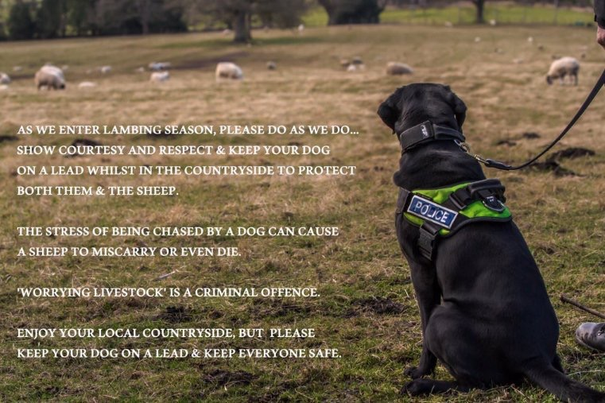
We are highlighting the dangers of dogs being walked off their leads, particularly during lambing season and are reminding everyone that sheep worrying is a criminal offence that can lead to fines of up to £1,000.
Every year, sheep and lambs are chased and sometimes killed by dogs that are let off their leads in rural areas. Large financial losses are often suffered by farmers as a result, and it leads to distressed and often aborted lambs.

Enjoy our countryside and make it safe for everyone.

