Mid Holderness Ward Newsletter – December 2024
Detailed crime and ASB data for your area can be obtained by visiting www.police.uk and following the ‘Find your Neighbourhood’ link.
Meet Your Community Police Team
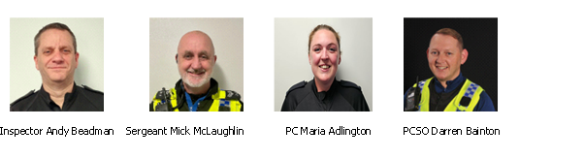 What’s happening in Your Area & Community Priorities?
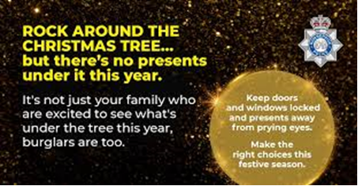
New: OPERATION YULETIDE – Visit our website for advice on how to stay safe this season will be sent out via MY COMMUNITY ALERT

17 crimes reported during November, (13 recorded in October 2024)
Humbertalking has set our priorities, this month we are to:
- Reduce ASB - improve the quality of life.
- Prevention of Residential dwelling Burglaries & vehicle crime.

Here’s a summary of crimes that have been reported across Mid Holderness last month:
- Residential Burglary reports: (six investigations)
9/11/2024 Burglary Seaside Road, ALDBROUGH via insecure door, nothing taken.
9/11/2024 Burglary North Street, ALDBROUGH via insecure door, nothing taken.
9/11/2024 Burglary Headlands Drive, ALDBROUGH via open window, nothing taken
9/11/2024 Burglary in an outbuilding High Street, ALDBROUGH
9/11/2024 attempt Burglary Seaside Road, ALDBROUGH door handle tried.
9/11/2024 attempt Burglary Seaside Road, ALDBROUGH door handle tried.
UPDATE: a 27year old Aldbrough man was arrested at 1014hours 9/11/24 and later charged for four offences, he is awaiting interview on two other offences.

- Business Burglary reports: (no reports)

- Thefts: (six investigations)
02/11/2024 Theft A165, LONG RISTON – Make off without payment for fuel.
10/11/2024 Theft A165, LONG RISTON – Make off without payment for fuel.
13/11/2024 Theft A165, LONG RISTON – Make off without payment for fuel.
20/11/2024 Theft A165, LONG RISTON – Make off without payment for fuel.
21/11/2024 Theft A165, LONG RISTON – Make off without payment for fuel.
27/11/2024 Theft Shaftesbury Villas, SKIRLAUGH – remove of trees from rear garden
- Vehicle Crime: (two investigations)
04/11/2024 theft of motorbike from layby, GARTON
11/11/2025 theft of caravan from roadside, FLINTON

- Damage: (three investigations)
05/11/2025 damage, Cherry Tree Close BILTON eggs thrown at property
23/11/2024 damage to crop, THIRTLEBY – 4X4 driven across winter crop.
26/11/2024 damage to garage door, Glebelands BURTON PIDSEA
Domestic Violence – 5 incidents reported.
18 other reports including Public order, harassment, fraud, neighbour disputes and anti-social behaviour reported in November across the Mid Holderness ward area.

Humber-talking has set our priorities, this month we are to:
1. Reduce ASB - Improve the quality of life in the community
This period is always one of our busiest, however, we would like to offer reassurance to those who are looking to enjoy Christmas and a stark reminder to those intent of causing harm or committing offences, that we are out in force and ready to act against anyone spoiling others’ fun.
UPDATE - During November, reports of anti-social behaviour have increased to 8 reports.
These include reports of quad bikes driven at speed along Greens Lane, Wawne, anti-social use of firework, and underage drinking in SKIRLAUGH.

Action - You will see a clear police presence on patrol in and around your neighbourhood over this period. We really want everyone to enjoy themselves, but we will be there to ensure we deal with any incidents quickly.

The Holderness Neighbourhood Policing Team works with our key partners and the community to reduce anti-social behaviour and the anti-social use of motor vehicles. We provide proactive responses to reports of anti-social behaviour in our neighbourhood Area and are constantly reviewing our patrol strategy to address this. We are working hard with partners to address this and ensure our market towns and rural communities are a safe place to live and work.

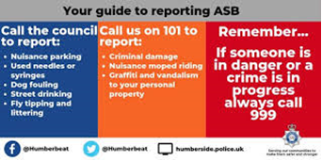

- Preventing Residential dwelling Burglaries
OPERATION YULETIDE is Humberside Police’s campaign in Preventing Residential dwelling Burglaries & vehicle crime during the festive season.
As the nights get darker and longer, it is usual for us to see crimes such as burglary and theft rise, particularly if houses and vehicles are unattended whilst you are shopping or just out enjoying the Christmas festivities.
Burglars are often opportunistic thieves who prey on houses, garages, sheds and outbuildings. They seek out any opening that they can take advantage of, specifically doors and windows that are left open or unlocked or are easy to force.
Please follow a security routine and check windows, doors and vehicles are secure before settling down for the evening. Visit our website for further advice www.humberside.police.uk
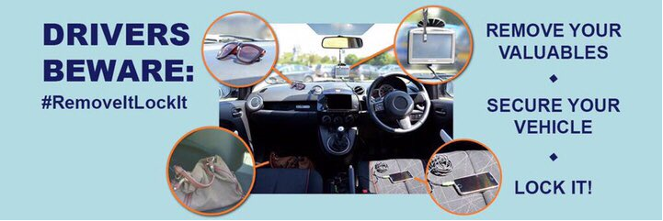
Action
During the winter months, members of the Holderness Policing Team will continue be out to Minimise crime and ASB.
Maximise crime reduction opportunities by targeting offenders and providing advice to homes and businesses. Minimise the risk of becoming a victim of crime through high visibility patrolling.

How you can help
Your local Neighbourhood Policing Team appreciates the importance of being in the right place, at the right time, for the right reasons to reassure the public, improve public confidence and reduce crime and anti-social behaviour in the area in which we all live and work.
We encourage all residents to call and report any issues where they live so that we can deal with any issues and step up our patrols in that area.
If you feel that there are other issues affecting you or your local community that should be given priority, please inform your local councillors or your Neighbourhood Policing Team.
News and Appeals
Please visit our website www.humberside.police.uk for the latest news & appeals
FACEBOOK users did you know? You can find out more about the work of your local officers and teams by liking their Facebook accounts: Please visit Humberside Police – East Riding of Yorkshire South www.facebook.com/HumberbeatERYS
Twitter (X) users can keep up to date with events, alerts and traffic news within Mid Holderness by following the community team @HumberbeatERYS and @PCSODarrenB
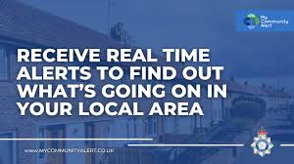 My Community Alert - free sign up

Engagements: In December 2024, the dates and locations are as follows:
1st- Sunday 5pm St.Peters Church Hall BILTON
6th- Friday 5pm Wawne Village Hall, WAWNE
21st- Saturday 11:30am the Village Hall, Swine Lane, CONISTON
Schools will be visited during the morning and afternoon commute.
Preventing stolen doorstep deliveries
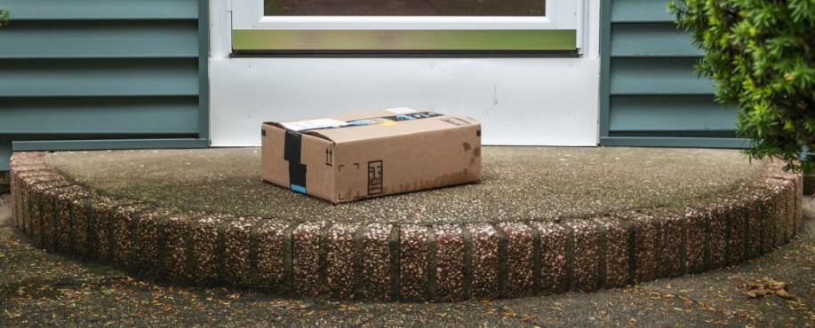
Practical advice to reduce the risk of being affected by the growing trend of theft of items left unattended by delivery drivers.
Here are some things you could do to reduce the risk of doorstep theft:
* track your parcel to ensure you or someone else is at home for the delivery.
* install a video doorbell; this can be connected to your mobile, so you are notified immediately of any delivery and is easier to install than a full CCTV system.
* install a security light.
* arrange for your parcel to be delivered to a trusted neighbour, or other family members who will be at home.
* use an off-site locker service for frequent deliveries, or for expensive items; these parcel boxes are more likely to be in busy, safer locations - such as supermarkets - rather than secluded areas which could be targeted by thieves.

“We Hope your holiday season is full of peace, joy and happiness."
Happy Christmas from everyone at Humberside Police

“Christmas for many people is a happy time of year, and an opportunity to enjoy spending some quality time relaxing with family and friends – and that is as it should be. However, disappointingly, this is also a time of year when we see spikes in crimes such as domestic abuse and drink and drug driving. So, as well as wanting to wish you all a very happy Christmas, I would also like to offer a reminder on some other important messages.

“Firstly, please don’t drink and drive. There is simply no need to, and it is totally unacceptable. It is easy to make alternative arrangements to get home and where this is possible, simply don’t drink or take drugs. There is simply no excuse to put your own or somebody else’s life at risk by making a decision to drive whilst under the influence, it’s not worth it.

“Secondly, we are committed to doing what we can to tackle domestic abuse, and together with our partners we are working to put a stop to it. However, we cannot achieve this if incidents are not reported, so we need your help too. Please have the confidence to take that first step, and make that call, where someone is waiting to help. If you are aware of domestic or indeed any abuse of another person, please report it to the police.

“On a happier note, this year I’ve been so lucky to meet so many people doing great things around our communities to help and support others. I know it can seem like a cliché or even patronising, but I am blessed in my job to feel the strength of the community spirit which makes and maintains Mid Holderness as the safe place that we have all come to appreciate and expect. I am so grateful to all the volunteers’ running clubs, organisations and partners who contribute to keeping our youngsters constructively busy, helping others and our communities to keep safe in a multitude of ways.

“I would also like to say a big ‘thank you’ to all the Police Officers, Special Constables and police staff for all their hard work over the last year to keep us safe and especially those that are working over the busy Christmas period. Our force has also again been recognised by Her Majesty’s Inspectors of Constabularies as being outstanding at what they do in several important reports this year. We are blessed to have a professional and dedicated force and I am sincerely grateful to every member of staff for their efforts on our behalf.

“I often talk about ‘we not they’ and Christmas is no different to any other time of year. We must all look out for ourselves and each other whether that is keeping our homes secure, looking out for neighbours, particularly the elderly who may be alone and vulnerable and who would always appreciate someone popping in to say hello, (please consider it – it won’t take a moment but would make somebody’s day) or reporting a crime.

“Finally, I would like to take this opportunity to wish you all a safe and peaceful Christmas and all the best for 2025. I love getting out and about on my beat, and hope to meet as many people as possible, it is only by listening to you that I can do my job effectively. 2025 will no doubt continue to present challenges, but I remain committed to working with all police departments, partner agencies and the public of Mid Holderness to keep our East Riding of Yorkshire County among the safest places in the country to live work and visit.

“Have a very Happy Christmas and a Wonderful New Year.”

Darren
PCSO Darren Bainton



